FIVE System

User Guide
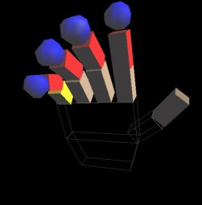

Fully

Interactive
Virtual
Environment

Contents:

Introduction 2
Setting up the system: 3

Installation 3
Preparing the glove 4

The hand movement gesture set 5

Advanced gesture set 8

Controlling your environment 9

Main Menu 10

The Environment Menu 10

Loading environments 10
Saving environments 10

The Object Menu 11

Altering created objects 11
Creating new objects 11

The Viewing Menu 12

Changing the view 12
Centering the view 12
Gun mode 12

Interacting with your environment 13

Objects 13
Actions performable on the objects 13

User Guide

Fully

Interactive
Virtual
Environment

Introduction:

FIVE (Fully Interactive Virtual Environment), is a graphical interface to computer created environments that permits a user to move and interact with objects in it. The interfacing is through the recognition of a user's hand gestures through a data glove. This user guide steps through the necessary steps to get FIVE installed and running on your computer. It also explains the means of interaction and how to create and manipulate virtual environments.

Within five a user can create an environment using existing objects, and interact with them in a variety of ways. Objects can be created deleted, deleted, picked up, moved, pushed and even shot at. The users actions are mirrored real time on screen and this adds to a feeling of presence in this virtual “non-space”. Objects react to collision between themselves and the virtual hand. All interaction with FIVE is via 5th Dimension Technologies data glove. FIVE is free of any keyboard control.

Setting up the system:

To install FIVE:

As FIVE is an OpenGL based library to run it, you must have OpenGL and the Glut3.7 extensions libraries installed.

The following files are needed to run FIVE:

FIVE.EXE -The executable

GloverDriver.dll - Glove serial communications utility

Image directory - Containing texture mapped images
Sound directory - Containing all sounds
World directory - Containing all world files

Unzip the file FIVE.zip and this will create and install the above files in their correct locations.

Connecting the data glove:
The 5DT data glove connects to the serial port of a computer via a 9-pin plug. Plug the 9-pin connector of the serial lead into a free COM port on your computer. FIVE will search all COM ports for the glove on start up.

The 5DT data glove utilizes a 9.5V centre positive power supply. Attach the power supply to the branched connector at the 9-pin plug end of the serial lead.

Plug the phone line type connector into the back of the interface box located on the top of the glove. On connection a red light on the interface box will light indicating that the glove has power.

Wearing the data glove:
The 5DT glove has two velcro fasteners around the wrist. To put it on, undo these and place the glove on your hand. To prevent the interface box on top of the glove from shifting during operation ensure that the velcro fasteners are tightly wrapped around your wrist.

A note on gestures:
Interaction with and movement within the environment is implemented by forming specific hand gestures. The FIVE gesture recognition system has a threshold level that allows for variation in hand movement from person to person but as too low a threshold would result in unwanted gestures being recognised it is important that gestures be preformed correctly, as otherwise they will not be recognised.

When a motion gesture is recognised the speed that the virtual hand moves is directly related to the amount of tilt or roll applied to the glove.

Due to the location of the roll and tilt sensor, to tilt the virtual hand simply tilting the wrist will not suffice. The optimum way to activate the tilt and roll sensors is to keep the wrist rigid and elevate the elbow above the wrist to tilt to glove forward and the opposite action to tilt back.

The hand movement gesture set:

There are only two gestures needed to navigate around the virtual environments of FIVE.

Gesture One:
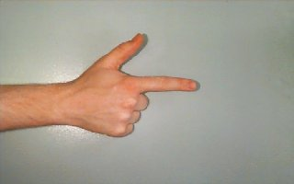
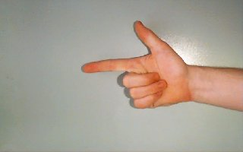
Point the index finger out keeping the rest of your fingers firmly closed.

Gesture Two:
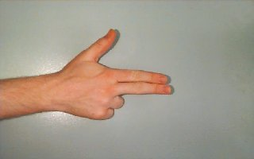
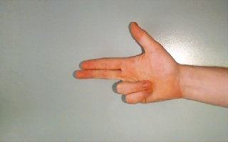
Point the index and middle fingers out keeping the rest of your fingers firmly closed.

To move forward:
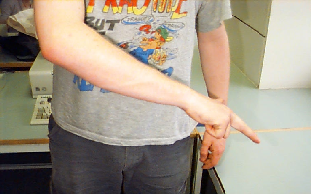
Making gesture one, tilt the hand down.

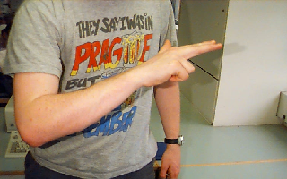
To move back:
Making gesture one, tilt the hand up.

To move left:
Making gesture one, roll the hand left.
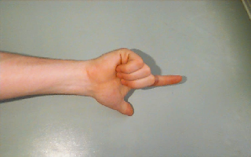

To move right:
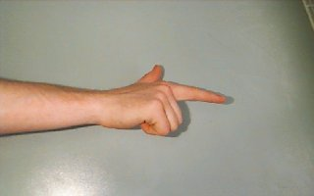
Making gesture one, roll the hand right.

To move up:
Making gesture two, tilt the hand up.

To move down:
Making gesture two, tilt the hand down.

Advanced gesture set:

Grasping and releasing an object:

To grasp an object the object must be in contact with the palm and at least one finger tip of the virtual hand. On making this contact the object will stick to the glove until it has been released by fully opening the hand, and brushing it away.

A special gesture is used especially to facilitate easy grasping of an object. Simply move up to the object in question, placing the glove directly to the right of the object. Open the virtual hand and roll it 90 degrees to the right as shown below.

An object can now be grasped by flexing the thumb, causing the glove to move toward the object and closing the hand around the object as it comes into range.

Controlling your environment:

There are several environmental controls that can be changed by the user via an on screen menu. To prevent the menu from being inadvertently summoned the gesture is one that would not normally be made in the course of natural hand movement.

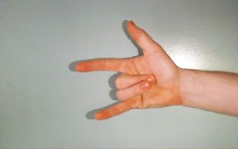
Menu
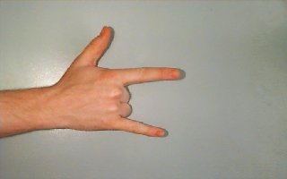
To summon it makes the following gesture:

Menu Options:
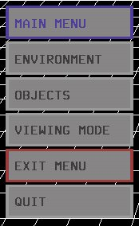
When the menu is visible the hand movement will change. Tilting the hand forward will move the red selector frame up the menu. Tilting the hand back will move the selector down. To make a choice make a fist. When a choice is made from the main menu one of the following sub menus will be opened, environment, objects, viewing mode if selected.

The menu is turned off if exit menu is chosen.

The application is exited if quit is chosen.
The sub-menus:

Each of the following sub-menus has a back button to return you to the “Main Menu”. After making a choice on a menu, by making a fist, you must then make an open hand to prevent accidentally choosing an option of the following sub-menu.

The environment menu:

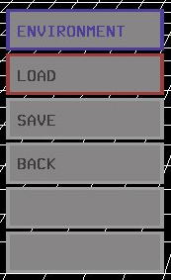
The “Environment” menu is used to load and save the current objects in your environment.

Load presents you with a choice of four worlds to load in. To load one simply highlight a world slot – World1, World2, World3 or World4. On selection the world will be loaded.

Save saves the current objects in the environment, choose the save option of the environment menu and then choose a slot to save it in.

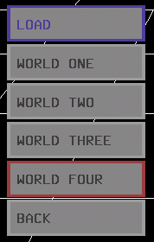
The “Load” menu is just like the “Save” menu in that you choose a slot to save/load a world into/from.

Saving/Loading a file will return you automatically to the environment and switches off the menu.

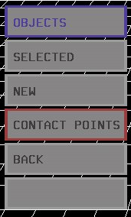
The objects menu:

The object menu gives the options to perform operations on the last object touched by the virtual hand.

Selected opens the “Selected Menu”.

New opens the “New Object Menu”

Contact Points is a toggle switch to turn on or off the visibility of all contact points. To facilitate their visibility all FIVE primitives are switched to wire frame mode.

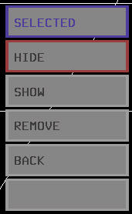
The selected menu presents several options, which will affect the last object touched by the virtual hand.

Hide makes the last object touched invisible.

Show will reverse the hide option and redisplay the object that has been hidden.

Remove completely deletes the object from the environment.

Back returns you to the main menu.

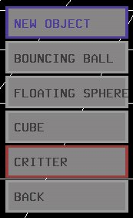
The “New Object” menu is used to create new objects in the world.

“Bouncing Ball” creates a bouncing ball in front of the hand.

“Floating Sphere” creates a floating rotating ball in front of the hand.

“Cube” creates a cube in front of the hand.

“Critter” creates “Dizzy” the dragonfly in front of the hand.
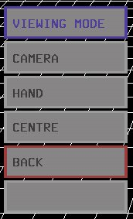
The “Viewing Mode” menu alters the behavior the hand

Camera maps all hand movement to moving the viewpoint of the world keeping the line of sight centered on the hand.

Hand returns the hand from camera mode to normal mode.

Centre returns the camera to a default location behind the hand.

Interacting with objects in the world:

Objects in the world.

Cube:
The properties of the Cube are such that it will not react to being collided with but other objects that hit it cannot pass through it.

Sphere:
A sphere floats in space rotating on its axis. It reacts to collision by moving out of the path of the colliding object unless it is picked up in which case it attaches itself to the hand.

Bouncing Ball:
A bouncing ball acts much the same as a floating sphere except that it is effect by gravity. If it is picked up and released above the floor it will fall, hit the floor and bounce back up towards the hand.

Critter:
The Critter navigates around the world independently. It can be picked up much the same as a sphere, but also has the added property of reacting to gunfire. It screams when a bullet hits it.

Actions preformed on the objects.

Pushing objects:
If an object is not anchored, then if will react to being hit by other objects. Objects may be “pushed” by moving towards them and touching the object in question with one of the 4 blue contact points on located at the end of the fingers. Attempting to push an object that is anchored e.g. Cube, will have no effect on it.

Pushing objects:
If an object is not anchored, then if will react to being hit by other objects. Objects may be “pushed” by moving towards them and touching the object in question with one of the 4 blue contact points on located at the end of the fingers. Attempting to push an object that is anchored e.g. Cube, will have no effect on it.

Grasping objects:
An unanchored object may also by picked up by the virtual hand. Gestures for picking up of objects is described in detail in “The advanced gesture set”. Once an object has been successfully picked up it can be brought to any desired point in the environment. The movment gestures function just as before but care should be taken to ensure that at least one finger remains closed around the object at all times to stop accidental release of the object.

Releasing objects:
Once an object has been brought to the desired co-ordinates it can be released by simply fully opening the hand and pushing it away with the fingertips.

Shooting objects:
Gun mode is a mode that can be selected off the view menu. Once it has been selected the user may fire bullets from the index finger by flexing the thumb. Reloading is preformed by fully opening the hand mimicking the release gesture. Bullets fired from the finger have only have effect if they hit a dragonfly, in which case the dragon fly screams with pain.

